1. Create one Declarative pipeline job <https://github.com/betawins/spring3-mvc-maven-xml-hello-world-1.git>

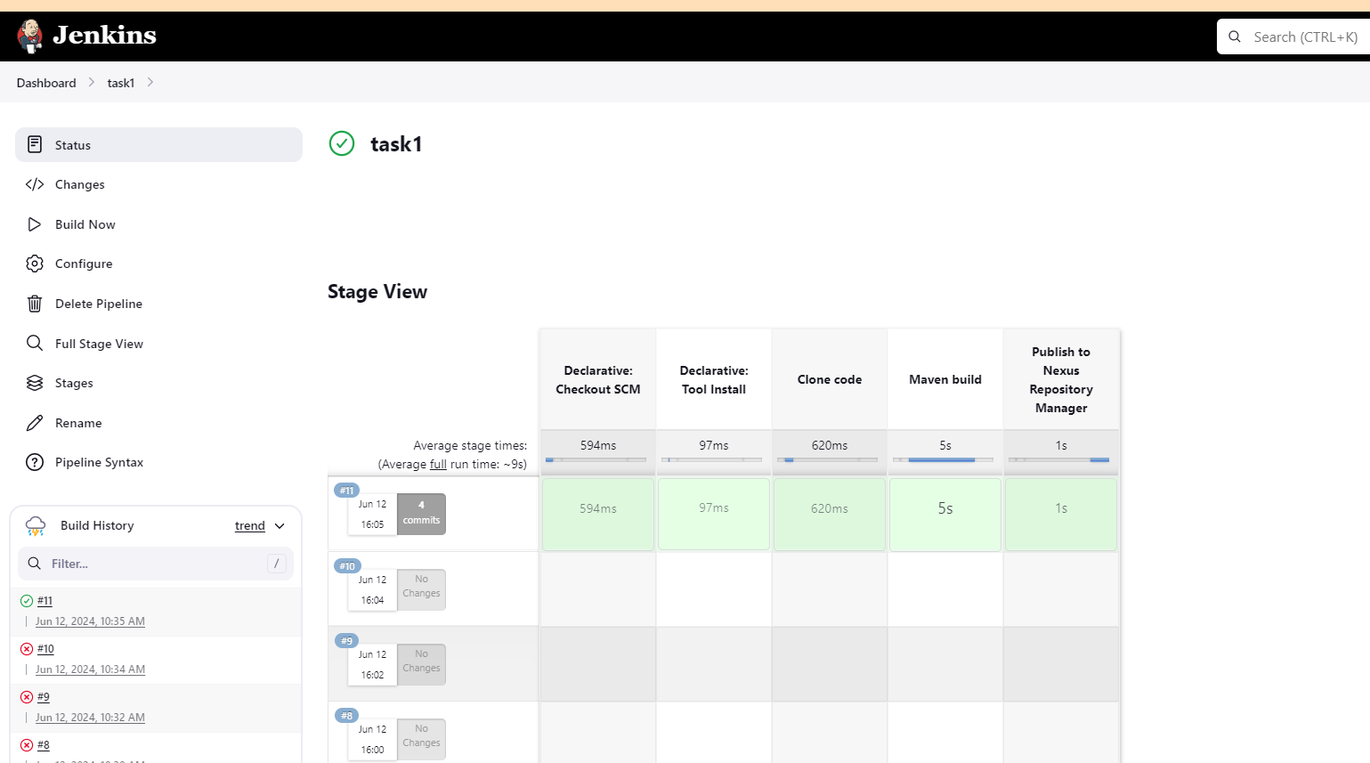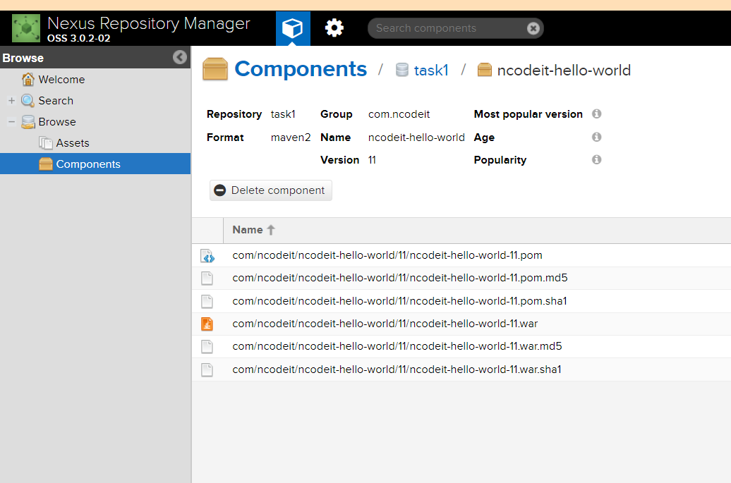

1. Create one scripted pipeline job <https://github.com/betawins/spring3-mvc-maven-xml-hello-world-1.git>

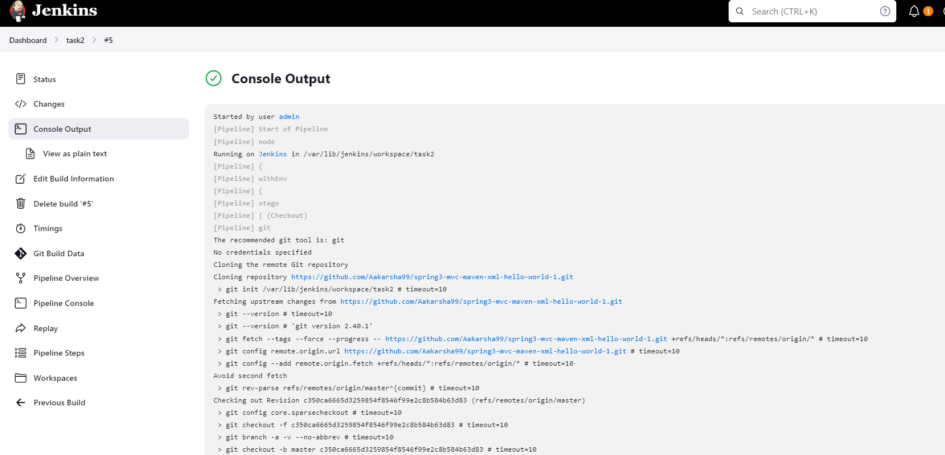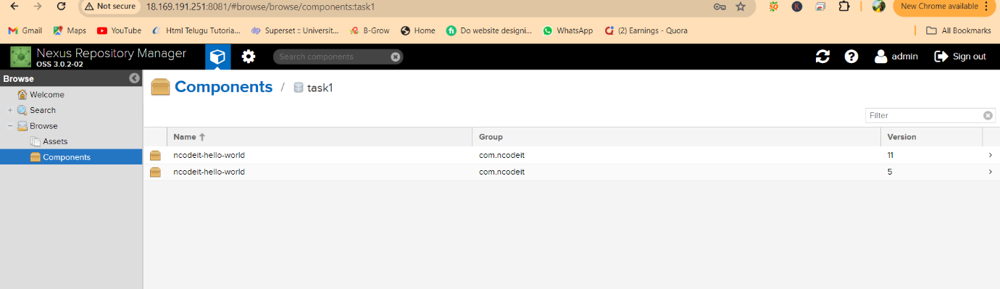

1. Create one parametirized job <https://github.com/betawins/spring3-mvc-maven-xml-hello-world-1.git>

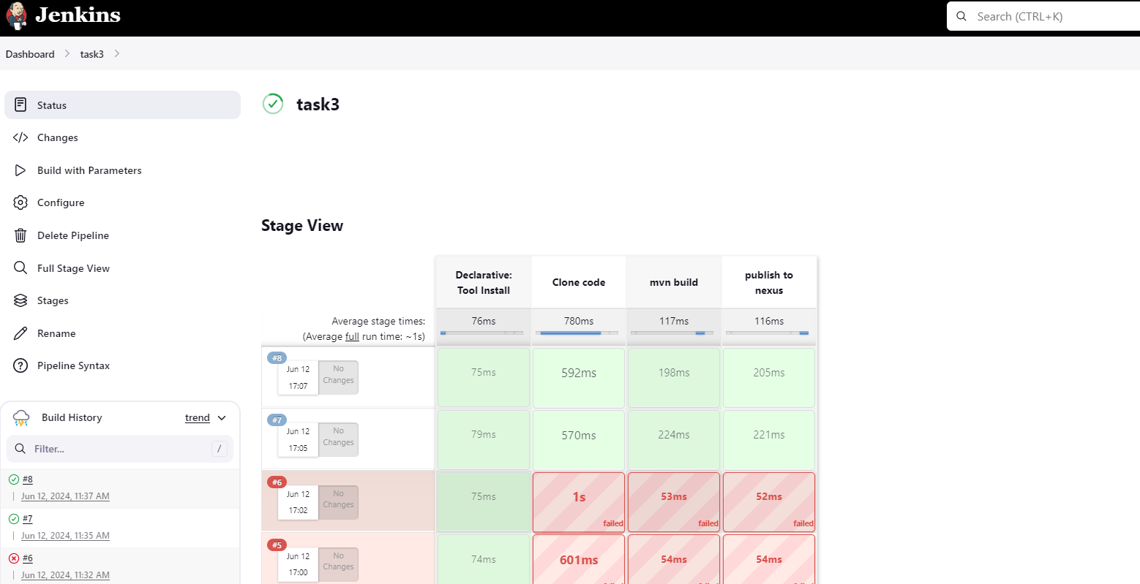

4) Write sample skelton for declarative and scripted pipelines.

|  |  |
| --- | --- |
| node {  stage('Build') {  echo 'Building...'  }  stage('Test') {  echo 'Testing...'  }  stage('Deploy') {  echo 'Deploying...'  }  } | pipeline {  agent any  stages {  stage('Build') {  steps {  echo 'Building...'  }  }  stage('Test') {  steps {  echo 'Testing...'  }  }  stage('Deploy') {  steps {  echo 'Deploying...'  }  }  }  } |

5) Create one declarative j ob <https://github.com/betawins/sabear_simplecutomerapp/tree/feature-1.1> 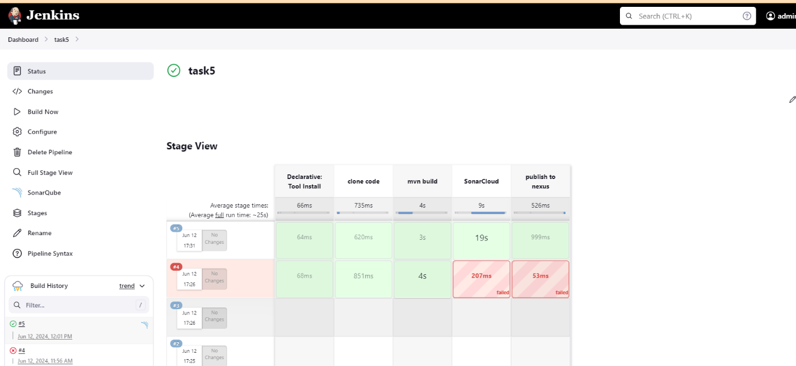

6) Create one declative job <https://github.com/betawins/Trading-UI.git>

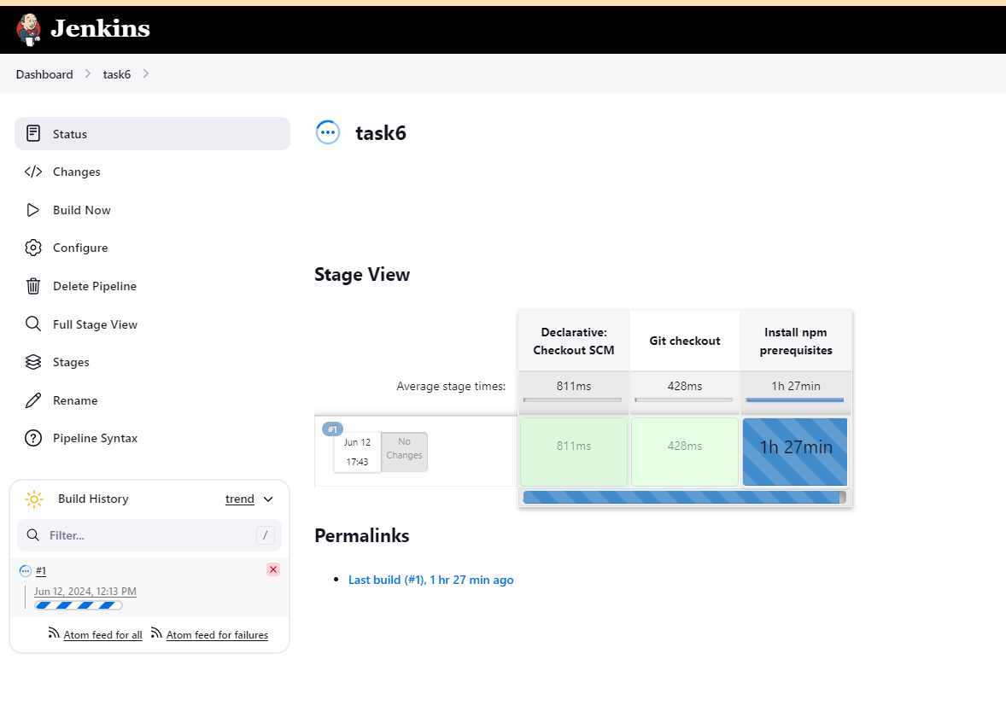

7) Execute parallel stages using jenkins pipeline for any sample job.

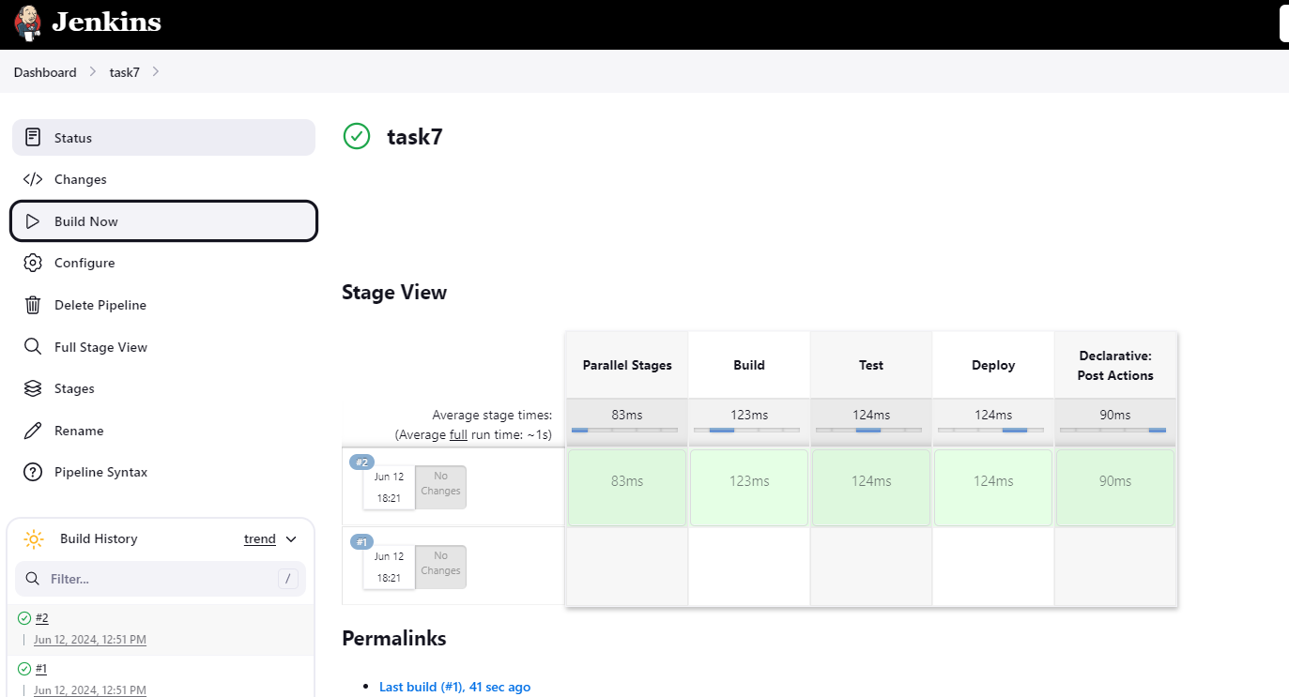

8) Execute jenkins pipeline stages using shared libraries. Ref: <https://phoenixnap.com/kb/jenkins-shared-library>